Ex.no:7
Date:18/4/25
7.Write a servlet to program to store a user’s preferences(like theme or language) using cookies.Retrive and display these preferences on subsequent visits.
Aim:
To Write a Servlet to demonstrate the difference between HTTP GET and POST
By creating a form and handling requests accordingly .

Program:
Cookie.html
<!DOCTYPE html>
<html>
<head>
<meta charset="ISO-8859-1">
<title>Insert title here</title>
</head>
<body>
<form method="post" action="http://localhost:7750/Dynamic_web_project_suba/Cookie1">
<p>
<label>Theme: </label>
<input type="text" name="theme" required>
</p>
<p>
<label>Language: </label><br>
<input type="radio" name="language" value="English" required> English<br>
<input type="radio" name="language" value="Tamil"> Tamil<br>
<input type="radio" name="language" value="Hindi"> Hindi<br>
</p>
<button type="submit">Submit</button>
</form>

</body>
</html>
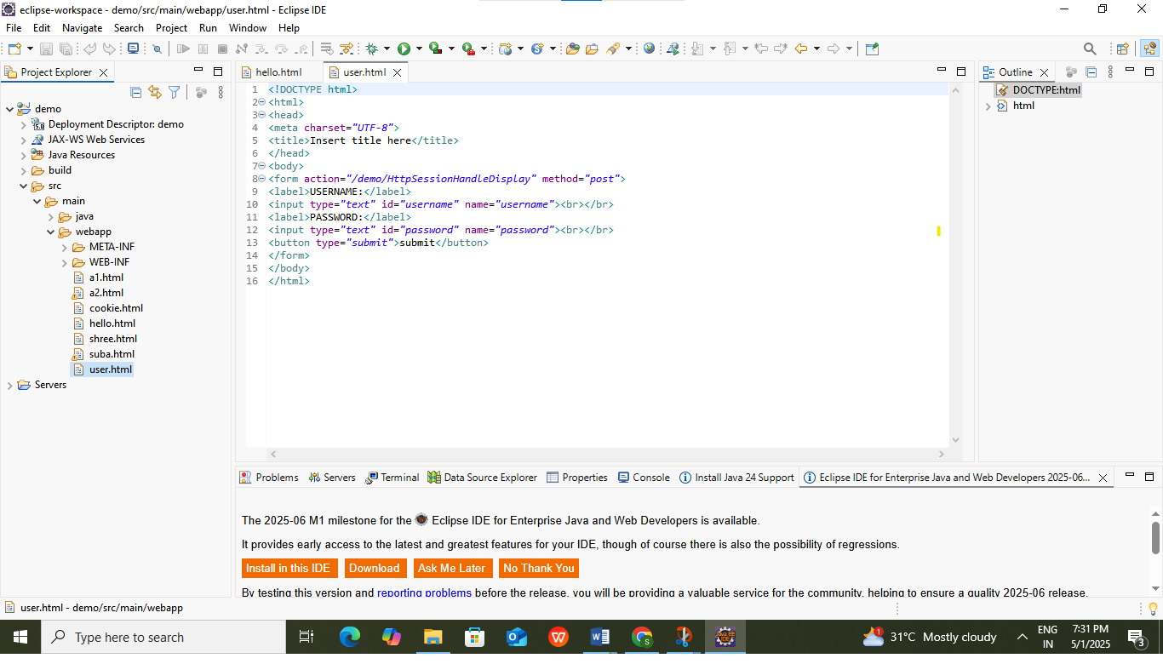
getCookie.jsp
<%@ page language="java" contentType="text/html; charset=ISO-8859-1" pageEncoding="ISO-8859-1"%>
<!DOCTYPE html>
<html>
<head>
<meta charset="ISO-8859-1">
<title>Get Cookie</title>
</head>
<body>
<%
Cookie[] cookies = request.getCookies();
String theme = null;
String language = null;

if (cookies != null) {
for (Cookie cookie : cookies) {
if ("theme".equals(cookie.getName())) {
theme = cookie.getValue();
} else if ("language".equals(cookie.getName())) {
language = cookie.getValue();
}
}
}

if (theme != null && language != null) {
out.println("Hi! Your theme is <b>" + theme + "</b> and preferred language is <b>" + language + "</b>.");
} else {
out.println("No cookies found.");
}
%>
</body>
</html>
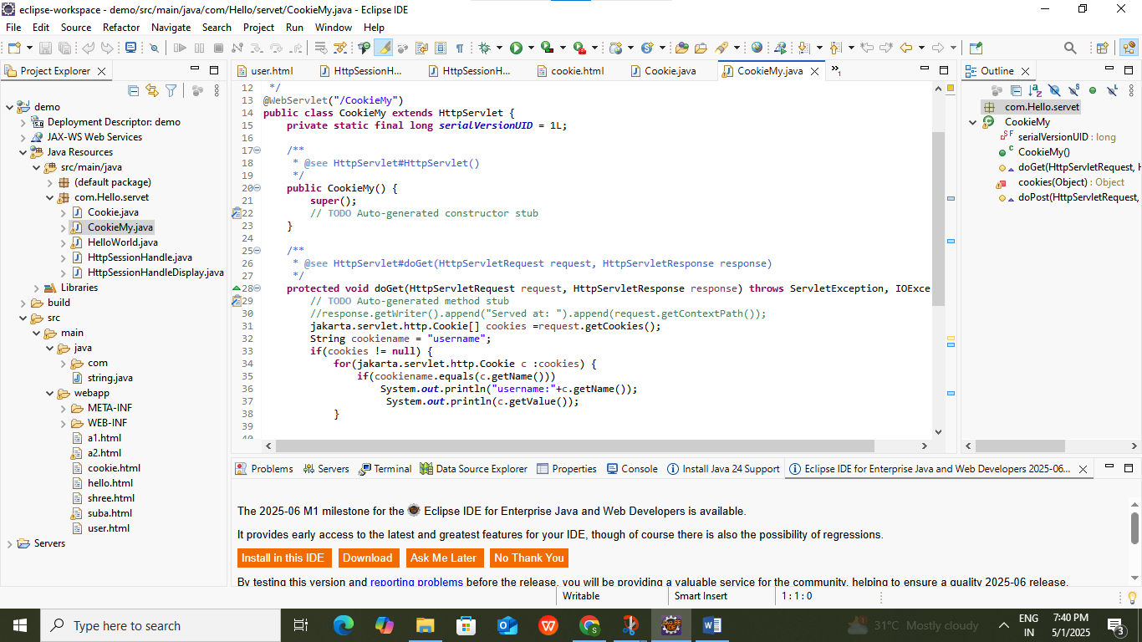

Cookie.java
package com.suba.servlet;

import java.io.IOException;
import javax.servlet.ServletException;
import javax.servlet.annotation.WebServlet;
import javax.servlet.http.Cookie;
import javax.servlet.http.HttpServlet;
import javax.servlet.http.HttpServletRequest;
import javax.servlet.http.HttpServletResponse;

@WebServlet("/Cookie1")
public class Cookie1 extends HttpServlet {
private static final long serialVersionUID = 1L;

public Cookie1() {
super();
}

protected void doPost(HttpServletRequest request, HttpServletResponse response) throws ServletException, IOException {
String theme = request.getParameter("theme");
String lang = request.getParameter("language");

// Check if values match specific criteria
if ("nature".equalsIgnoreCase(theme) && "tamil".equalsIgnoreCase(lang)) {
// Create cookie with proper name and value
Cookie themeCookie = new Cookie("theme", theme);
themeCookie.setMaxAge(60 * 60); // 1 hour
themeCookie.setPath("/");
response.addCookie(themeCookie);

Cookie languageCookie = new Cookie("language", lang);
languageCookie.setMaxAge(60 * 60);
languageCookie.setPath("/");
response.addCookie(languageCookie);

response.sendRedirect("getCookie.jsp");
} else {
response.getWriter().println("Invalid login!");
}
}
}
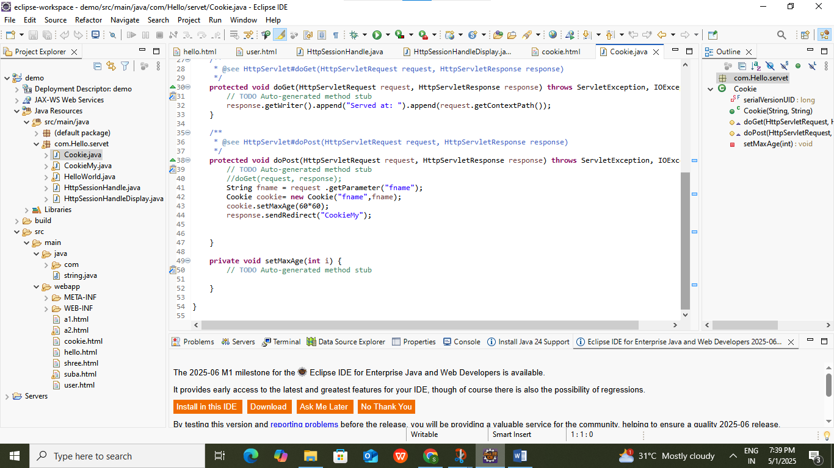

Output:
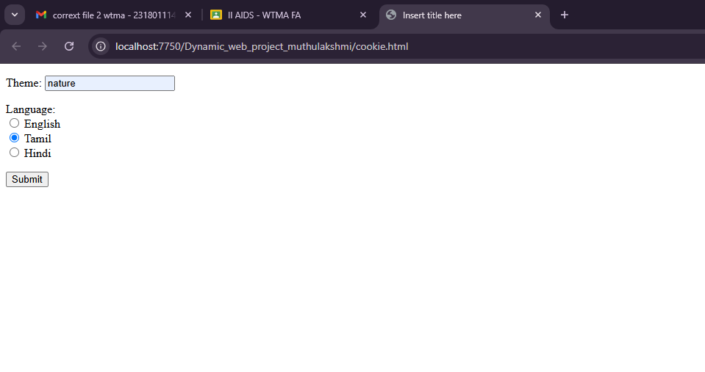

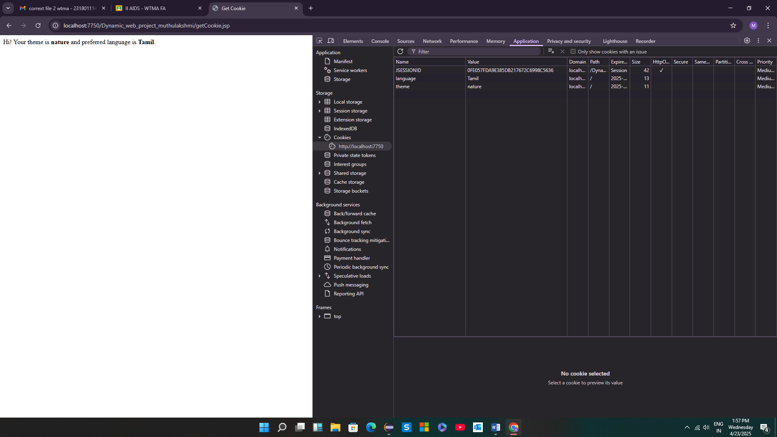

Result:
Thus Write a servlet to program to store a user’s preferences(like theme or language) using cookies.Retrive and display these preferences on subsequent visits.

